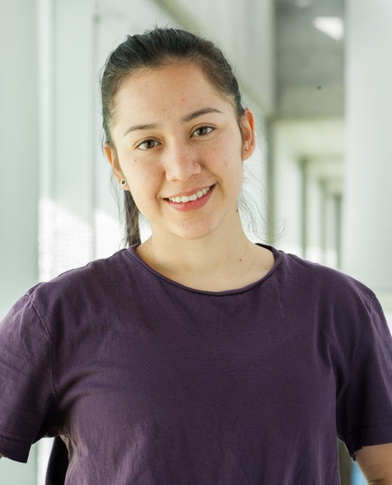
YUMA ARIAS
Age: 25
Nationality: Mexican
Height: 151cm – 5’
Weight: 49kg – 105lbs
E-mail: ariasyumad@gmail.com

MAIN DISCIPLINES:
- Acro-dance (Duo)
- Contortion
- Manipulation de hula hoop

EDUCATION
- Currently graduating from national circus school
Montreal Qc. program DEE 3
- Rhythmic gymnastics, national level 2004-2011
Coach: Elvira Mustaeva
- SICCED level 1 (Sports Training and Certification System)
National School of Sports Coaches, CONADE

EXPERIENCE
- Contortionist in “Rhythms of the night” directed by Debra Brown 2014-2016
Puerto Vallarta, Mexico

- Performer in “Les minutes” au Festival Montréal complètement cirque, directed by Anthony Venisse, 2019
Montreal, Qc, Canada

- Performer in Triptique “Sous la chamise” by Marc Béland 2019
École Nationale de Cirque, Montreal, Qc, Canada

- Performer in “Cirque Symphonique’’ by Marie-Josée Gauthier, with the Longueuil Symphony Orchestra 2019
Théatre de la Ville à Longueil, Qc, Canada

- Animation by Meaghan Wegg 2018
Tohu, Montreal, Qc, Canada

- Animation “Circusical” by Edgar Zendejas 2017
Tohu, Montreal, Qc, Canada
- Contortionist in “Circolodum” 2012-1014
Puerto Vallarta, Mexico

- Performer in “Gala Vallarta” by Irene Guerediaga 2013
Puerto Vallarta, Mexico

- Performer in Arcano’s concert 2013 and 2014
Vallarta Theather, Puerto Vallarta and Diana theather, Guadalajara, Mexico

- VidaFest circus festival 2014
Malecon Puerto Vallarta, Mexico

- Rhythmic gymnastics coach (Competition level) 2011-2014
CODEM Puerto Vallarta, Mexico

COMPLEMENTARY SKILLS
-Dance (classic ballet and contemporary dance)
-Manipulation of ribbon, hula hoop, ball, rope and clubs
-Basic techniques in handstand, cyrwheel, juggling.

